# NAME: TOWOJU OLUWADAMILOLA JOY

# MATRIC NO: 20CJ027492

# COURSE CODE: CEN 524

# PROGRAM: COMPUTER ENGINEERING

1. 1. Write an algorithm for summing of the Taylor series. (Hint: f(x) = f(a)(x − a) + [f '(a)/2! .(x−a). 2] + [f ''(a)/3! .(x − a) .3] + ….. + [f n (a)/n! .(x − a) n]; let f(a), f '(a)….. f n (a) be an array of input terms and a is a real number)

**SOLUTION**

Title: Taylor Series Sum Calculation

Input:

• Array of derivatives f(a), f’(a), f’’(a), ..., fⁿ(a)

• Real number a

• Value x

• Number of terms n

Initialize: sum = 0, factorial = 1

Expressions:

1. For i from 0 to n-1:

o If i > 0, update factorial = factorial * i

o Term = F[i] * ((x - a)^i) / factorial

Sum = Sum + Term

Return Value:

• The approximated sum of the Taylor series f(x).

1. With an algorithm, write out the procedure for calculating the factorial of a given integer n; (i.e. n!).

**SOLUTION**

Algorithm for Calculating Factorial (n!)

Title: Factorial Calculation

Input: Integer n

Initialize: Factorial = 1

Expressions:

For i = 1 to (n + 1) then:

Compute fact = fact * i = i!.

End For

Return Value:

The factorial of n (n!).

1. With the aid of an algorithm, write out the procedure for calculating the Pearson’s Correlation Coefficient of two variables (x and y)

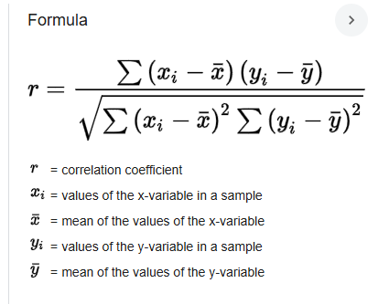

Title: Pearson’s Correlation Calculation

Input: Two lists x[] and y[] , r

Initialize: mean of x (x̄) and mean of y (ȳ), numerator = 0, denominator = 0, result = 0

Expressions: numerator = Sum of [(xi − xˉ) × (y − yˉ)]

denominator= √[〖sum of (xi - xˉ)〗^2 × sum of (y - yˉ)^2]

Result = numerator/Denominator

Return Value:

Pearson’s correlation coefficient r

1. Write an algorithm for Newton’s Iterative Formula to find the Reciprocal of a Number N and state the timing Notation [𝐻𝑖𝑛𝑡: 𝑥𝑖+1 = 𝑥𝑖(2 – 𝑥𝑖𝑁)] Assume x0 = 0.1 and N = 5; show how global minimum converges at each iteration

Algorithm for Newton’s Iterative Formula for Reciprocal of Nxi+1=xi×(2−N×xi)

where: Xi is the current approximation.

Xi+1 is the next improved approximation.

Title: Newton’s Iterative Reciprocal Calculation

Input: N = 5, X0 = 0.1, Iterations = 10

Initialize: X0 = Xi

Expressions: For i = 0 to iterations – 1

Then xi+1=xi×(2−N×xi)

End For

Return Value: Approximate reciprocal of N

Let's go through the iterative steps in detail to show how the global minimum (the reciprocal of N=5) converges at each iteration using Newton's Iterative Formula.

Given:

* N=5N
* X0=0.1(Initial guess)
* max_iterations=10

We apply Newton’s Iterative Formula:

Xn +1=Xn×(2−N×Xn)

We will calculate the iterations step-by-step.

**Iteration 1 (Start with X0=0.1):** X1=X0×(2−N×X0)

Substituting N=5

X1=0.1×(2−5×0.1)= 0.1×1.5 = 0.15

* **Iteration 1:** X1=0.15
* **Iteration 2:** X2=0.1875
* **Iteration 3:** X3=0.19921875
* **Iteration 4:** X4=0.2001953125
* **Iteration 5:** X5=0.20001220703125
* **Iteration 6:** X6=0.20000000015449524
* **Iteration 7:** X7=0.20000000000000001

This shows how the method quickly converges towards the true reciprocal which is 0.2